1. 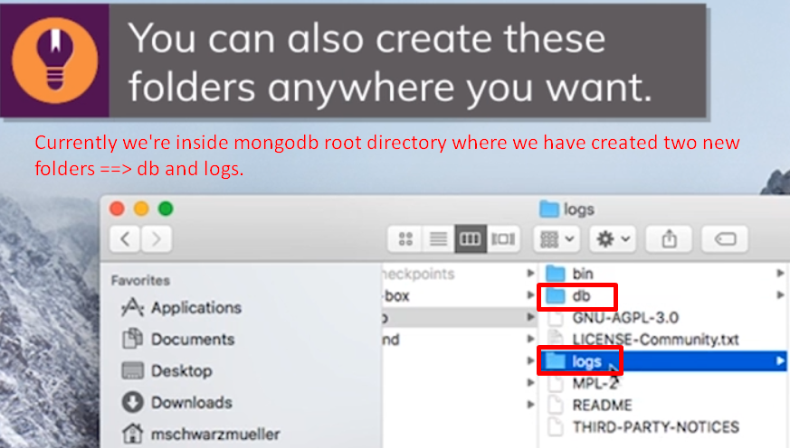
2. **Db**: To store db files
3. **Logs**: To store log files.
4. Running mongodb server along with specifying the path for db files.  
   **Command**:  
   
   1. It would create a bunch of files and folders in the specified file.
   2. Now it’s using different database storage. It’s not totally detached from the previous database. Now we have a totally brand new database setup because we are using different file storage for the database.
5. Running MongoDB server along with specifying the log file path.  
   
6. 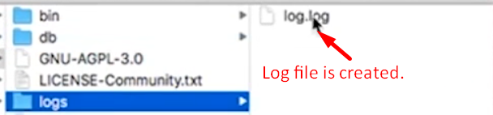
7. See
   1. **Warnings**: Access control is not enabled.
   2. **Errors**: